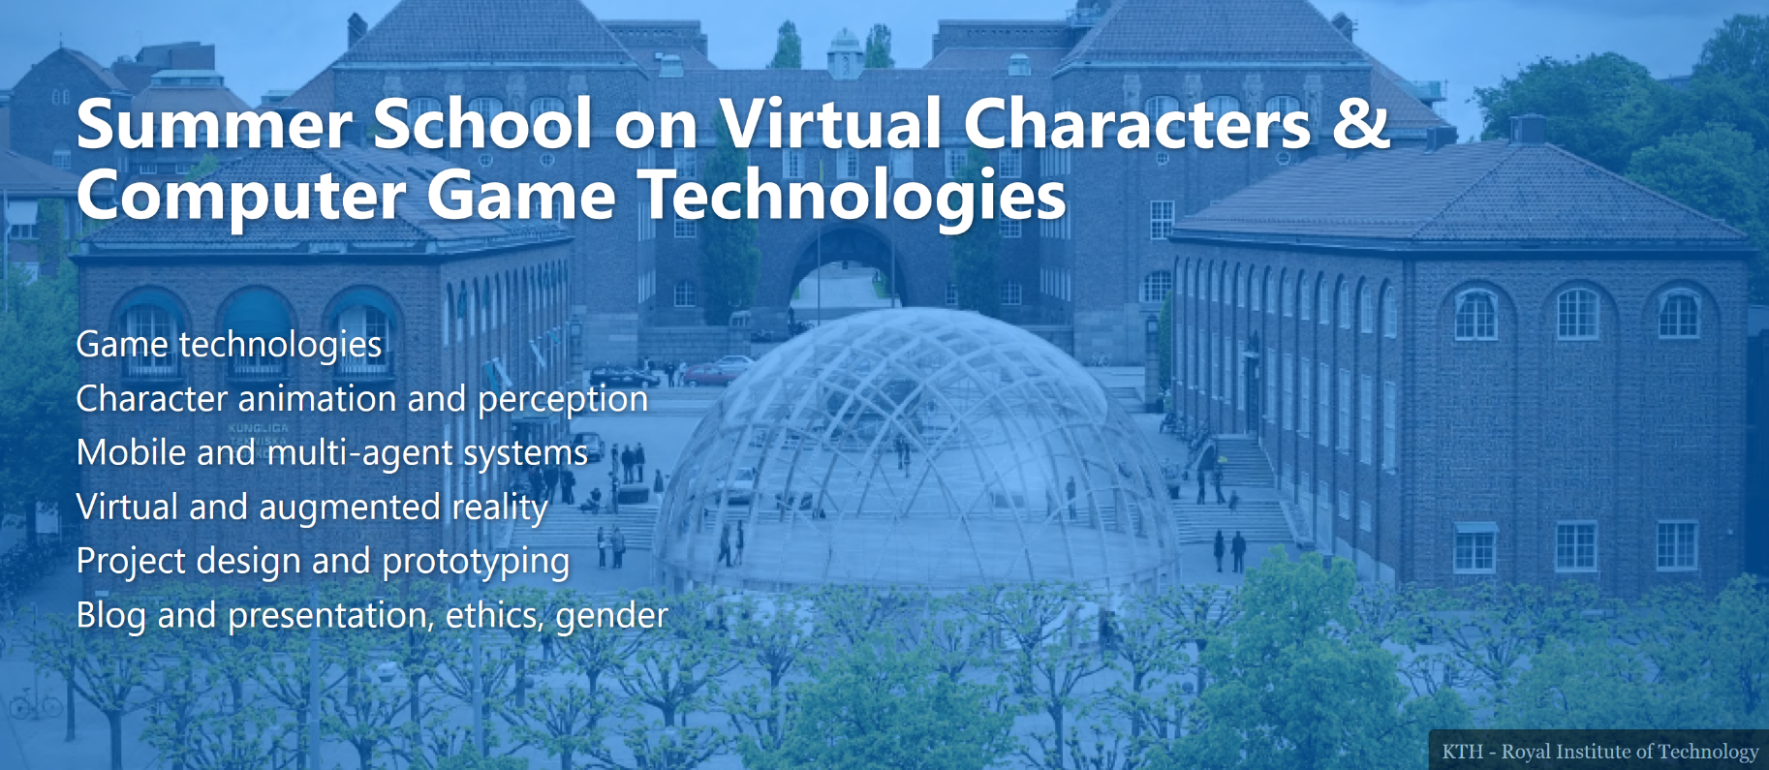

**KEYNOTES**

***(tentative details)***

|  |  |
| --- | --- |
| Keynote: **Agents, robots and situated Intelligence**  Speaker: **Sean Andrist, Microsoft Research** | |
| My goal is to enable natural language-based interactions with embodied technologies (robots and virtual agents) that can both perceive and appropriately respond to human conversational verbal and nonverbal social cues. To accomplish that goal, I explore techniques to improve an agent's awareness of the social context around it and couple that enhanced representation with behaviors that can improve the agent's task and social capabilities, user acceptance, rapport, and in general enable these technologies to be better "citizens" of the environment they are embedded within. |  |
| In this keynote, I’ll describe my efforts designing, building, and evaluating socially interactive technologies that are physically situated in the open world, particularly embodied virtual agents and robots. I will also describe the open-source platform I’ve been working on with others here at MSR, called the *Platform for Situated Intelligence*. | |

|  |  |
| --- | --- |
| Keynote: **Virtual characters and human perception**  Speaker: **Carol O’ Sullivan, GV2, Trinity College Dublin** | |
| Carol O'Sullivan is the Professor of Visual Computing in Trinity College Dublin, and Head of the School of Computer Science and Statistics. From 2013-2016 she was a Senior Research Scientist at Disney Research in Los Angeles, and spent a sabbatical year as Visiting Professor in Seoul National University from 2012-2013. She joined TCD as a lecturer in 1997 and served as the Dean of Graduate Studies from July 2007 to July 2010. Her research interests include graphics and perception, Computer Animation, Crowd and Human simulation. She has managed a range of projects with significant budgets during that time and successfully supervised many doctoral and post-doctoral researchers. Prior to her PhD studies, she spent several years in industry working in Software Development. She was elected a fellow of Trinity College for significant research achievement in 2003 and of the European Association for Computer Graphics (Eurographics) in 2007. |  |
|  | |
|  | |
| Keynote: **Virtual reality and interactive systems**  Speaker: **Julien Castet, Head of Research, Immersion SA** | |
| TBA |  |
|  | |

|  |  |
| --- | --- |
| Keynote: **Gamified human-robot/agent interaction**  Speaker: **André Pereira, KTH** | |
| I am a researcher at the Division of Speech, Music and Hearing (TMH) at KTH. I design, implement and evaluate socially intelligent systems, typically robots, that can interact naturally with people in human-centered domains like education, healthcare, and entertainment. My primary research objective is to create autonomous embodied intelligent systems that can socially interact, in real-time, with human users throughout extended periods. These systems can establish social relationships, simulate empathy and emotions, generate believable gaze and dialog. |  |
| In this keynote, I’ll describe my work with physical robots and embodied virtual characters in interactive game scenarios involving children and adults. | |
|  | |
| Keynote: **Developing social robotic applications with Furhat**  Speaker: **Gabriel Skantze, Furhat Robotics** | |
| Gabriel Skantze is co-founder and chief scientist at Furhat Robotics. He is also Professor in speech technology with a specialization in dialog systems at the Department of Speech Music and Hearing at KTH, where he is leading several interdisciplinary research projects related to modelling turn-taking, joint attention and grounding in human-robot interaction. |  |
| Furhat Robotics is developing a software and hardware platform for social robotics, with customers such as Disney Research, Honda and Merck developing social robotic applications for public spaces, health care, recruitment and entertainment. In this presentation, I will talk about what makes Furhat special compared to other social robots, and how social robotic applications can be developed with our SDK. | |

*With special guest and round table chair…*

|  |  |
| --- | --- |
| **Bilge Mutlu** is an Associate Professor of Computer Science, Psychology, and Industrial Engineering at the University of Wisconsin–Madison. He directs the Wisconsin HCI Laboratory and organize the WHCI+D Group. He received my PhD degree from Carnegie Mellon University‘s Human-Computer Interaction Institute. His research program builds human-centered methods and principles for designing robotic technologies that help people communicate, work, and pursue personal goals and draws on a transdisciplinary design research process that combines aspects of design, computer science, and social and cognitive sciences. |  |